Business Report

SMDM Project Business Report DSBA

***Sanjay Srinivasan***

***PGP-DSBA Online***

***JULY’ 21 Batch***

***Date: 23-01-2022***

# *INDEX*

|  |  |  |
| --- | --- | --- |
| ***S. No*** | ***Contents*** | ***Page* No** |
| **1.** | **Problem - 1** | 5 |
|  | Summary | 5 |
|  | Introduction | 5 |
|  | Data Description | 5 |
|  | 1) Read the dataset. Do the descriptive statistics and do the null value condition check. Write an inference on it. | 6 |
|  | Sample Dataset | 6 |
|  | Exploratory Data Analysis | 6 |
|  | Checking for missing values in the dataset | 6 |
|  | 2) **Perform Univariate and Bivariate Analysis. Do exploratory data analysis. Check for Outliers.** | 7 |
|  | 3) **Encode the data (having string values) for Modelling. Is Scaling necessary here or not? Data Split: Split the data into train and test (70:30)** | 10 |
|  | 4) **Apply Logistic Regression and LDA (linear discriminant analysis).** | 11 |
|  | 5) **Apply KNN Model and Naïve Bayes Model. Interpret the results.** | 15 |
|  | 6) **Model Tuning, Bagging (Random Forest should be applied for Bagging), and Boosting.** | 19 |
|  | 7) **Performance Metrics: Check the performance of Predictions on Train and Test sets using Accuracy, Confusion Matrix, Plot ROC curve and get ROC_AUC score for each model. Final Model: Compare the models and write inference which model is best/optimized.** | 25 |
|  | 8) **Based on these predictions, what are the insights?** | 25 |
|  |  |  |
| **2.** | **Problem - 2** | 26 |
|  | Summary | 26 |
|  | Introduction | 26 |
|  | 1) **Find the number of characters, words, and sentences for the mentioned documents** | 26 |
|  | 2) **Remove all the stopwords from all three speeches.** | 26 |
|  | 3) **Which word occurs the most number of times in his inaugural address for each president? Mention the top three words. (after removing the stopwords).** | 27 |
|  | 4) **Plot the word cloud of each of the speeches of the variable. (after removing the stopwords) – 3 Marks [ refer to the End-to-End Case Study done in the Mentored Learning Session ].** | 29 |

# *List Of Tables*

|  |  |  |
| --- | --- | --- |
| ***S.No*** | ***Content*** | ***Page No*** |
| 1.1 | Dataset sample | 6 |
| 1.2 | Datatypes of the variable | 6 |
| 1.3 | Check null values | 6 |

|  |  |  |
| --- | --- | --- |
| ***S.No*** | ***Content*** | ***Page No*** |
| 1.1 | Countplot for Blair | 7 |
| 1.2 | Univariate Analysis | 7 |
| 1.3 | Scatterplot for Bivariate Analysis | 8 |
| 1.4 | Multivariate analysis of pairplot | 8 |
| 1.5 | Multivariate analysis for correlation | 9 |
| 1.6 | Multivariate analysis of plotting correlation in heatmap | 9 |
| 1.7 | Checking for outliers | 10 |
| 1.8 | Dataframe after scaling | 10 |
| 1.9 | Sample Dataframe before Encoding | 11 |
| 1.10 | Sample Dataframe after Encoding | 11 |
| 1.11 | Boxplot after Scaling | 11 |
| 1.12 | Sample dataframe after dropping target variable | 11 |
| 1.13 | Parameters for GridsearchCV in Logistic Regression | 11 |
| 1.14 | Best parameter for Logistic Regression | 11 |
| 1.15 | Best estimator for Logistic Regression | 11 |
| 1.16 | Predicted values from the train dataset of Logistic Regression model | 12 |
| 1.17 | confusion matrix from Train data of Logistic Regression | 12 |
| 1.18 | Confusion matrix from test data of Logistic Regression | 12 |
| 1.19 | Classification Report from train data of Logistic Regression | 12 |
| 1.20 | Classification Report from test data of Logistic Regression | 12 |
| 1.21 | AUC and ROC curve train data of Logistic Regression | 12 |
| 1.22 | AUC and ROC curve test data of Logistic Regression | 13 |
| 1.23 | Predicted values from the train dataset of LDA model | 13 |
| 1.24 | Predicted values from the test dataset of Logistic Regression model | 13 |
| 1.25 | Model score for Training data | 13 |
| 1.26 | Model score for Testing data | 13 |
| 1.27 | confusion matrix from Train data of LDA | 14 |
| 1.28 | confusion matrix from test data of LDA | 14 |
| 1.29 | Classification Report from train data of LDA | 14 |
| 1.30 | Classification Report from test data of LDA | 14 |
| 1.31 | AUC and ROC curve train data of LDA | 14 |
| 1.32 | AUC and ROC curve test data of LDA | 15 |
| 1.33 | Comparing Logistic Regression vs LDA (Linear Discriminant Analysis) | 15 |
| 1.34 | Initializing KNN Classifier | 15 |
| 1.35 | Model score for Training data | 15 |
| 1.36 | Model score for Testing data | 15 |
| 1.37 | confusion matrix from Train data of KNN | 16 |
| 1.38 | confusion matrix from test data of KNN | 16 |
| 1.39 | Classification Report from train data of KNN | 16 |
| 1.40 | Classification Report from test data of KNN | 16 |
| 1.41 | AUC and ROC curve train data of KNN | 16 |
| 1.42 | AUC and ROC curve test data of KNN | 17 |
| 1.43 | Initializing NB Algorithm | 17 |
| 1.44 | Model score for Training data | 17 |
| 1.45 | Model score for Testing data | 17 |
| 1.46 | confusion matrix from Train data of NBA | 17 |

***List Of Figures***

|  |  |  |
| --- | --- | --- |
| 1.47 | confusion matrix from test data of NBA | 17 |
| 1.48 | Classification Report from train data of NBA | 17 |
| 1.49 | Classification Report from test data of NBA | 18 |
| 1.50 | AUC and ROC curve train data of NBA | 18 |
| 1.51 | AUC and ROC curve test data of NBA | 18 |
| 1.52 | Comparing KNN (K-Nearest Neighbors Classifier) vs NBA (Naive Bayes Algorithm) | 19 |
| 1.53 | Initializing Decision Tree Classifier | 19 |
| 1.54 | Best Parameters of Decision Tree Classifier | 19 |
| 1.55 | Model score for Training data | 19 |
| 1.56 | Model score for Testing data | 19 |
| 1.57 | confusion matrix from Train data of DTCL | 19 |
| 1.58 | confusion matrix from test data of DTCL | 19 |
| 1.59 | Classification Report from train data of DTCL | 20 |
| 1.60 | Classification Report from test data of DTCL | 20 |
| 1.61 | AUC and ROC curve train data of DTCL | 20 |
| 1.62 | AUC and ROC curve test data of DTCL | 20 |
| 1.63 | Important features of DTCL | 21 |
| 1.64 | Initializing BGCL Algorithm | 21 |
| 1.65 | Model score for Training data | 21 |
| 1.66 | Model score for Testing data | 21 |
| 1.67 | confusion matrix from Train data of BGCL | 21 |
| 1.68 | confusion matrix from test data of BGCL | 21 |
| 1.69 | Classification Report from train data of BGCL | 21 |
| 1.70 | Classification Report from test data of BGCL | 22 |
| 1.71 | AUC and ROC curve train data of BGCL | 22 |
| 1.72 | AUC and ROC curve test data of BGCL | 22 |
| 1.73 | Initializing ABCL Algorithm | 23 |
| 1.74 | Model score for Training data | 23 |
| 1.75 | Model score for Testing data | 23 |
| 1.76 | confusion matrix from Train data of ABCL | 23 |
| 1.77 | confusion matrix from test data of ABCL | 23 |
| 1.78 | Classification Report from train data of ABCL | 23 |
| 1.79 | Classification Report from test data of ABCL | 23 |
| 1.80 | AUC and ROC curve train data of ABCL | 24 |
| 1.81 | AUC and ROC curve test data of ABCL | 24 |
| 1.82 | Comparing Decision tree Classifier) vs. Bagging classifier (Using Random forest algorithm) vs. Adaboosting classifier | 24 |
| 1.83 | Comparing output from each model. | 25 |
| 2.1 | Number of Character,words and sentences for President D.Roosevelt | 26 |
| 2.2 | Number of Character,words and sentences for President F. Kennedy | 26 |
| 2.3 | Number of Character, words and sentences for President Richard Nixon | 26 |
| 2.4 | Sample President Roosevelt speech after removing stopwords | 26 |
| 2.5 | No of words count before and after removing of stopwords for President Roosevelt | 27 |
| 2.6 | Sample President Kennedy speech after removing stopwords | 27 |
| 2.7 | No of words count before and after removing of stopwords for President Kennedy | 27 |
| 2.8 | Sample President Nixon speech after removing stopwords | 27 |
| 2.9 | No of words count before and after removing of stopwords for President Nixon | 27 |
| 2.10 | Top 3 words from President Roosevelt speech | 28 |
| 2.11 | Words occurred most number of time from President Roosevelt speech | 28 |
| 2.12 | Top 3 words from President Kennedy speech | 28 |
| 2.13 | Words occurred most number of time from President Kennedy speech | 28 |
| 2.14 | Top 3 words from President Nixon speech | 28 |
| 2.15 | Words occurred most number of time from President Nixon speech | 29 |
| 2.16 | Word cloud from President Roosevelt speech after removing stopwords | 29 |
| 2.17 | Word cloud from President Kennedy speech after removing stopwords | 30 |
| 2.18 | Word cloud from President Nixon speech after removing stopwords | 30 |

# Problem - 1

*Summary*

The data is gathered from the leading news channels CNBE, which deals in analysing recent election. You are hired by the leading news channels CNBE, This survey was conducted on 1525 voters with 9 variables. You have to build a model, to predict which party a voter will vote for on the basis of the given information, to create an exit poll that will help in predicting overall win and seats covered by a particular party.

*Introduction*

The purpose of this exercise is to explore the dataset and make the predictions for which party will get a high vote and wins the election.

*Data Description*

|  |  |  |  |  |  |  |  |  |  |  |  |  |  |  |  |  |  |  |
| --- | --- | --- | --- | --- | --- | --- | --- | --- | --- | --- | --- | --- | --- | --- | --- | --- | --- | --- |
| |  | | --- | | 1. vote: Party choice: Conservative or Labour | |  | | 2. age: in years | |  | | 3. economic.cond.national: Assessment of current national economic conditions, 1 to 5. | |  | | 4. economic.cond.household: Assessment of current household economic conditions, 1 to 5. | |  | | 5. Blair: Assessment of the Labour leader, 1 to 5. | |  | | 6. Hague: Assessment of the Conservative leader, 1 to 5. | |  | | 7. Europe: an 11-point scale that measures respondents' attitudes toward European integration. High scores represent ‘Eurosceptic’ sentiment. | |  | | 8. political.knowledge: Knowledge of parties' positions on European integration, 0 to 3. | |  | | 9. gender: female or male. | |  |
|  |  |
|  |  |
|  |  |
|  |  |
|  |  |
|  |  |
|  |  |
|  |  |
|  |  |

**1.1 Read the dataset. Do the descriptive statistics and do the null value condition check. Write an inference on it.**

*Sample of the dataset:*

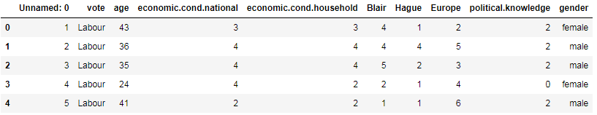

Table 1.1 Dataset Sample

*Exploratory Data Analysis*

*Let us check the types of variables in the data frame.*

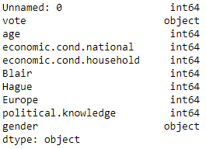

Table- 1.2. Datatypes of the variable

There are total 1525 rows and 10 columns in the dataset. 2 columns are object and 8 columns are int64

*Check for missing values in the dataset:*

From this we can infer that there are no null values present in the data.

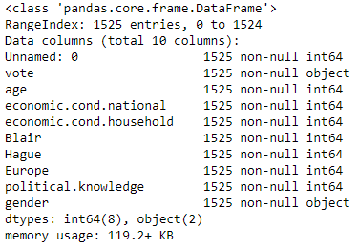

Table- 1.3. Check null values

**1.2 Perform Univariate and Bivariate Analysis. Do exploratory data analysis. Check for Outliers.**

***Uni-Variate Analysis:***

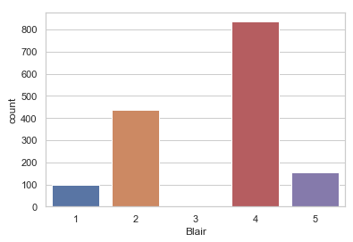

Fig – 1.1 countplot for Blair

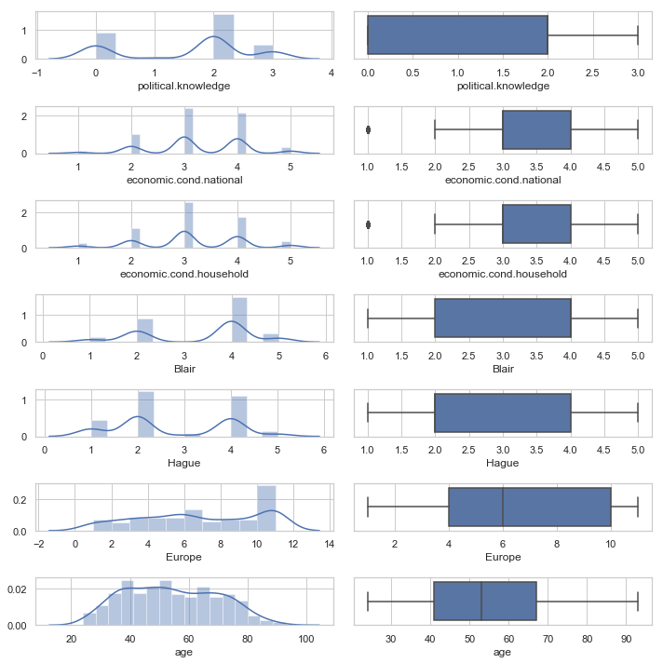

Fig – 1.2 Univariate Analysis

From the above chart (displot and boxplot), there are outliers present in the economic.cond.national and economic.cond.household data. We can infer that there is no trend or pattern that it follows a normal distribution.

***Bi – variate Analysis:***

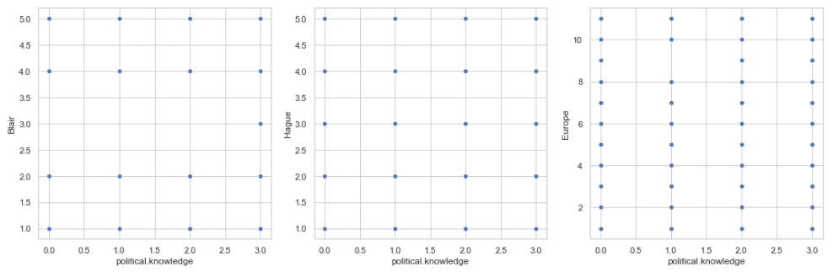

Fig – 1.3 Scatterplot for Bivariate Analysis

### From the scatterplot, we can infer that there is no relation between these data.

***Multi – variate Analysis:***

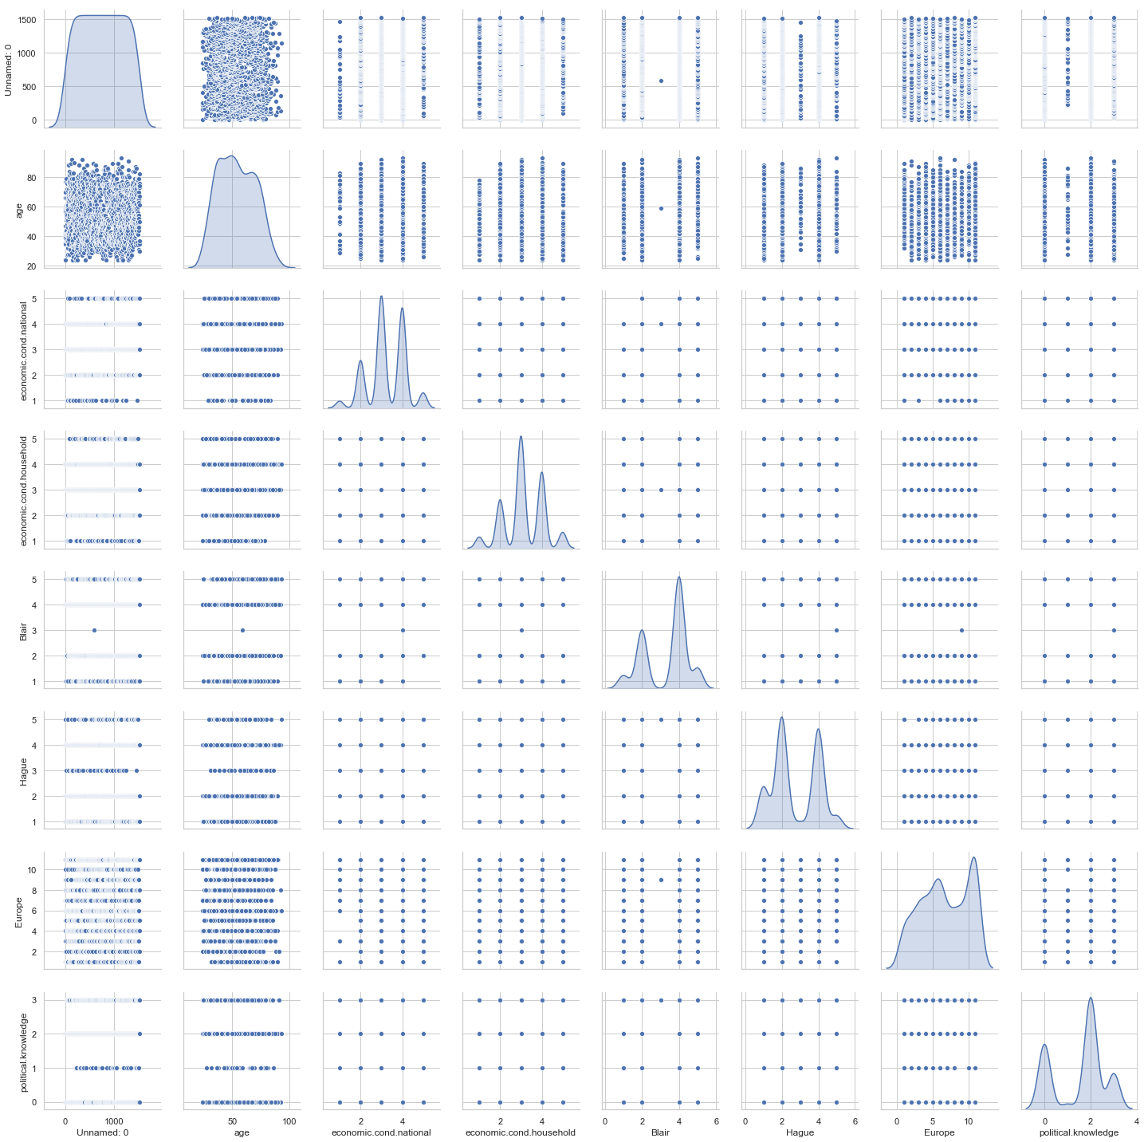

Fig – 1.4 Multivariate analysis of pairplot

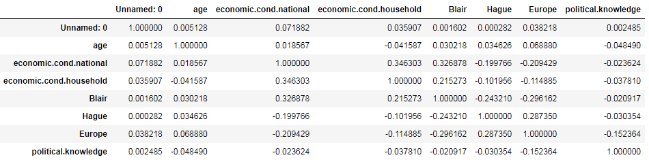

Fig – 1.5 Multivariate analysis for correlation

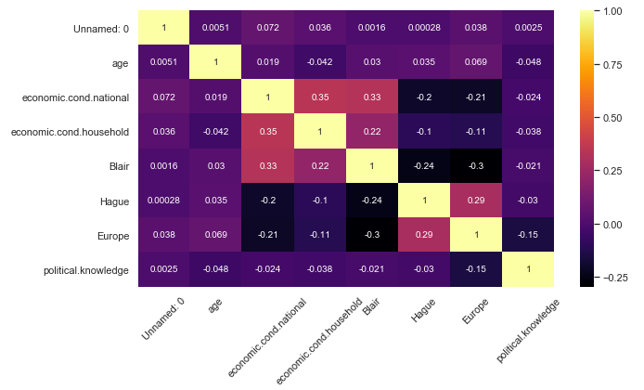

Fig – 1.6 Multivariate analysis of plotting correlation in heatmap

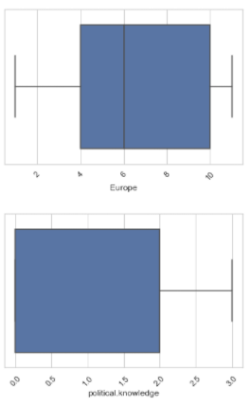

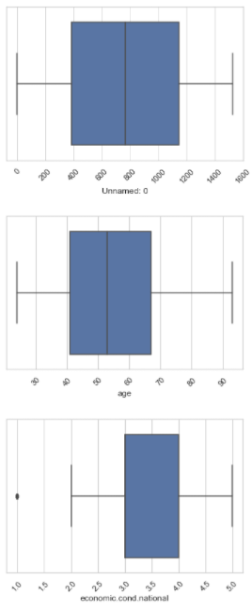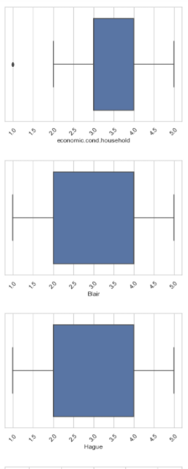

Fig – 1.7 Checking for outliers

From the above boxplot, we can infer that, the outliers are present in "economic.cond.national", "economic.cond.household". It is not needed to treat the outlier.

### 1.3 Encode the data (having string values) for Modelling. Is Scaling necessary here or not? Data Split: Split the data into train and test (70:30)

### Since Age is in different scale with other independent variables, scaling is needed.

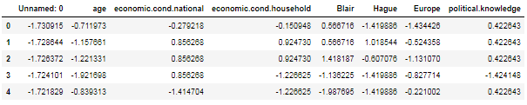

Fig – 1.8 Dataframe after scaling

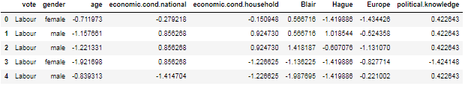

Fig – 1.9 Sample Dataframe before Encoding

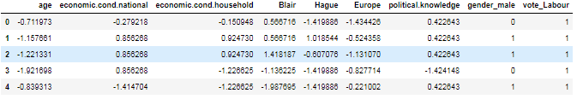

Fig – 1.10 Sample Dataframe after Encoding

***After Scaling:***

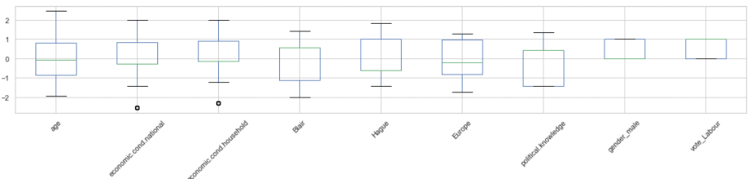

Fig – 1.11 Boxplot after Scaling

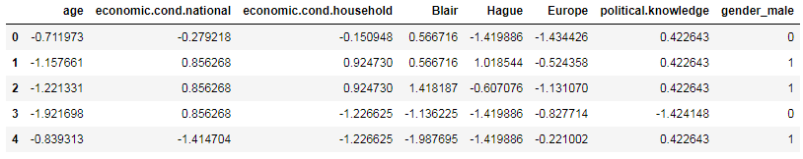

Fig – 1.12 Sample dataframe after dropping target variable

**1.4 Apply Logistic Regression and LDA (linear discriminant analysis). (4 marks)**

***Logistic Regression:***

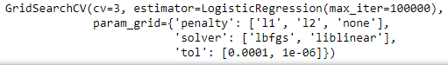

Fig – 1.13 Parameters for GridsearchCV in Logistic Regression

The best parameters are identified from the decision tree algorithm by using the grid search CV.



Fig – 1.14 Best parameter for Logistic Regression



Fig – 1.15 Best estimator for Logistic Regression

The values are predicted from the train data.



Fig – 1.16 Predicted values from the train dataset of Logistic Regression model

Confusion Matrix is obtained from the train data and test data using Logistic Regression.



Fig 1.17 confusion matrix from Train data of Logistic Regression



Fig 1.18 confusion matrix from test data of Logistic Regression

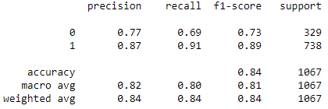

Fig 1.19 Classification Report from train data of Logistic Regression

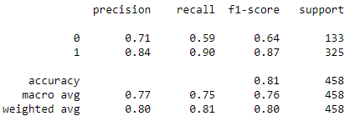

Fig 1.20 Classification Report from test data of Logistic Regression

**ROC curve** (**receiver operating characteristic curve**) is a graph showing the performance of a classification model at all classification thresholds. This curve plots two parameters.

* True Positive Rate
* False Positive Rate

The probability of the Area under the ROC curve for the train data is 89.5%

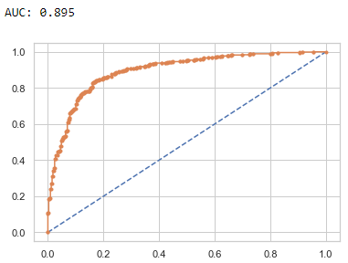

Fig 1.21 AUC and ROC curve train data of Logistic Regression

The probability of the Area under the ROC curve for the train data is 87.2%

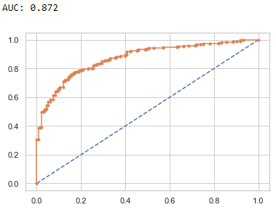

Fig 1.22 AUC and ROC curve test data of Logistic Regression

***LDA:***

The values are predicted from the train data.



Fig – 1.23 Predicted values from the train dataset of LDA model

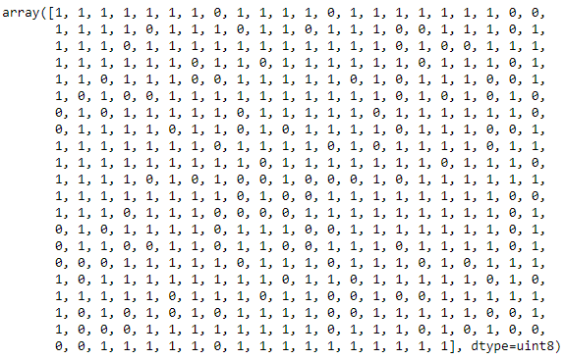

Fig – 1.24 Predicted values from the test dataset of Logistic Regression model



Fig – 1.25 Model score for Training data



Fig – 1.26 Model score for Testing data

Confusion Matrix is obtained from the train data and test data using LDA.



Fig 1.27 confusion matrix from Train data of LDA



Fig 1.28 confusion matrix from test data of LDA

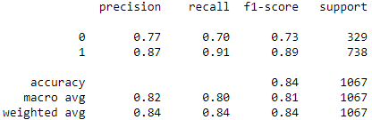

Fig 1.29 Classification Report from train data of LDA

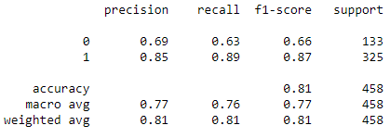

Fig 1.30 Classification Report from test data of LDA

**ROC curve** (**receiver operating characteristic curve**) is a graph showing the performance of a classification model at all classification thresholds. This curve plots two parameters.

* True Positive Rate
* False Positive Rate

The probability of the Area under the ROC curve for the train data is 89.5%

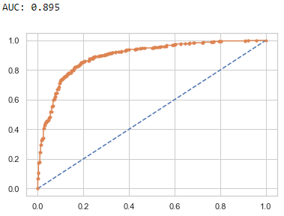

Fig 1.31 AUC and ROC curve train data of LDA

The probability of the Area under the ROC curve for the train data is 87.2%

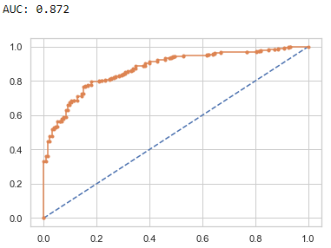

Fig 1.32 AUC and ROC curve test data of LDA

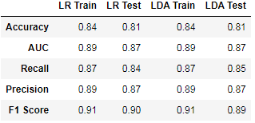

Fig – 1.33 Comparing Logistic Regression vs LDA (Linear Discriminant Analysis)

From the above table, we can infer that the accuracy and AUC for train and test data in logistic regression and LDA are same. recall, precision and F1 score are close to each other in both training and testing data. From the output, Logistic regression and LDA gives good result.

### 1.5 Apply KNN Model and Naïve Bayes Model. Interpret the results.

***K-Nearest Neighbors Classifier:***

The values are predicted from the train data.



Fig – 1.34 Initializing KNN Classifier



Fig – 1.35 Model score for Training data



Fig – 1.36 Model score for Testing data

Confusion Matrix is obtained from the train data and test data using KNN Classifier.



Fig 1.37 confusion matrix from Train data of KNN



Fig 1.38 confusion matrix from test data of KNN

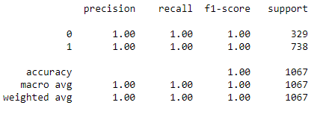

Fig 1.39 Classification Report from train data of KNN

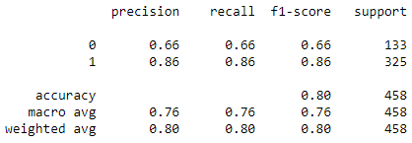

Fig 1.40 Classification Report from test data of KNN

**ROC curve** (**receiver operating characteristic curve**) is a graph showing the performance of a classification model at all classification thresholds. This curve plots two parameters.

* True Positive Rate
* False Positive Rate

The probability of the Area under the ROC curve for the train data is 100%

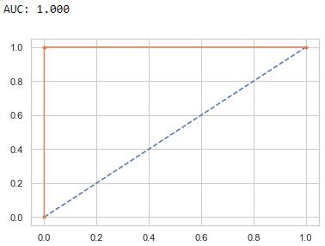

Fig 1.41 AUC and ROC curve train data of KNN

The probability of the Area under the ROC curve for the train data is 84.1%

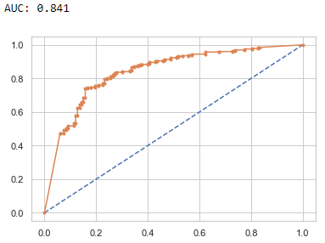

Fig 1.42 AUC and ROC curve test data of KNN

***Naive Bayes algorithm:***

The values are predicted from the train data.



Fig – 1.43 Initializing NB Algorithm



Fig – 1.44 Model score for Training data



Fig – 1.45 Model score for Testing data

Confusion Matrix is obtained from the train data and test data using Naïve Bayes Algorithm.



Fig 1.46 confusion matrix from Train data of NBA



Fig 1.47 confusion matrix from test data of NBA

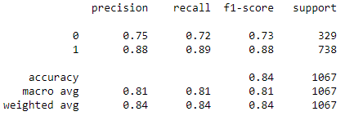

Fig 1.48 Classification Report from train data of NBA

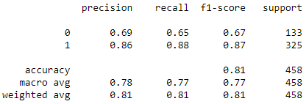

Fig 1.49 Classification Report from test data of NBA

**ROC curve** (**receiver operating characteristic curve**) is a graph showing the performance of a classification model at all classification thresholds. This curve plots two parameters.

* True Positive Rate
* False Positive Rate

The probability of the Area under the ROC curve for the train data is 89.2%

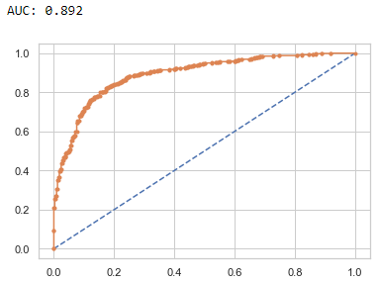

Fig 1.50 AUC and ROC curve train data of NBA

The probability of the Area under the ROC curve for the train data is 86.7%

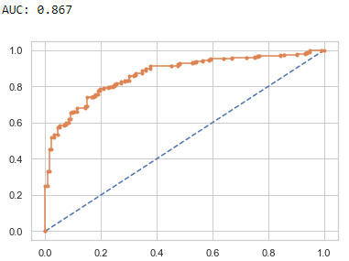

Fig 1.51 AUC and ROC curve test data of NBA

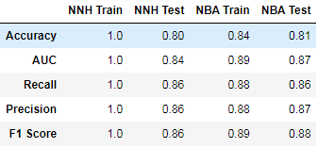

Fig – 1.52 Comparing KNN (K-Nearest Neighbors Classifier) vs NBA (Naive Bayes Algorithm)

From the above table, we can infer that Naive Bayes Algorithm gives the better result for testing data.

### 1.6 Model Tuning, Bagging (Random Forest should be applied for Bagging), and Boosting.

***K-Nearest Neighbors Classifier:***

The values are predicted from the train data.

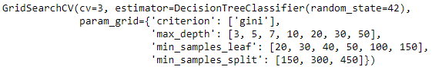

Fig – 1.53 Initializing Decision Tree Classifier

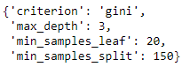

Fig – 1.54 Best Parameters of Decision Tree Classifier



Fig – 1.55 Model score for Training data



Fig – 1.56 Model score for Testing data

Confusion Matrix is obtained from the train data and test data using DT Classifier.



Fig 1.57 confusion matrix from Train data of DTCL



Fig 1.58 confusion matrix from test data of DTCL

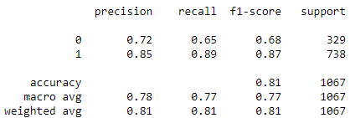

Fig 1.59 Classification Report from train data of DTCL

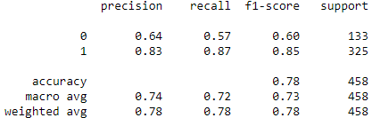

Fig 1.60 Classification Report from test data of DTCL

**ROC curve** (**receiver operating characteristic curve**) is a graph showing the performance of a classification model at all classification thresholds. This curve plots two parameters.

* True Positive Rate
* False Positive Rate

The probability of the Area under the ROC curve for the train data is 86.5%

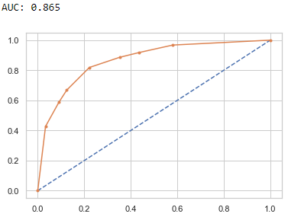

Fig 1.61 AUC and ROC curve train data of DTCL

The probability of the Area under the ROC curve for the train data is 84.1%

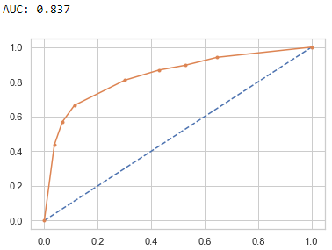

Fig 1.62 AUC and ROC curve test data of DTCL

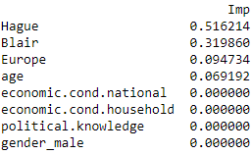

Fig 1.63 Important features of DTCL

***Bagging Classifier (Using Random Forest Algorithm):***

The values are predicted from the train data.

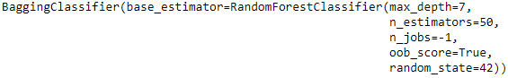

Fig – 1.64 Initializing BGCL Algorithm



Fig – 1.65 Model score for Training data



Fig – 1.66 Model score for Testing data

Confusion Matrix is obtained from the train data and test data using Bagging Classifier (Using Random Forest Algorithm).



Fig 1.67 confusion matrix from Train data of BGCL



Fig 1.68 confusion matrix from test data of BGCL

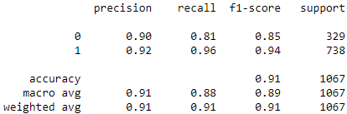

Fig 1.69 Classification Report from train data of BGCL

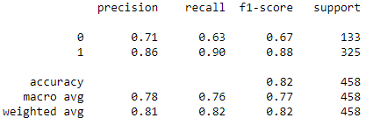

Fig 1.70 Classification Report from test data of BGCL

**ROC curve** (**receiver operating characteristic curve**) is a graph showing the performance of a classification model at all classification thresholds. This curve plots two parameters.

* True Positive Rate
* False Positive Rate

The probability of the Area under the ROC curve for the train data is 96.2%

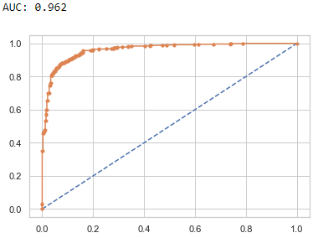

Fig 1.71 AUC and ROC curve train data of BGCL

The probability of the Area under the ROC curve for the train data is 88.6%

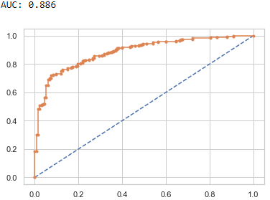

Fig 1.72 AUC and ROC curve test data of BGCL

***Boosting Classifier(AdaBoost) :***

The values are predicted from the train data.



Fig – 1.73 Initializing ABCL Algorithm



Fig – 1.74 Model score for Training data



Fig – 1.75 Model score for Testing data

Confusion Matrix is obtained from the train data and test data using AdaBoosting Classifier .



Fig 1.76 confusion matrix from Train data of ABCL



Fig 1.77 confusion matrix from test data of ABCL

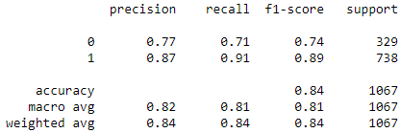

Fig 1.78 Classification Report from train data of ABCL

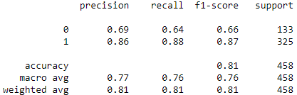

Fig 1.79 Classification Report from test data of ABCL

**ROC curve** (**receiver operating characteristic curve**) is a graph showing the performance of a classification model at all classification thresholds. This curve plots two parameters.

* True Positive Rate
* False Positive Rate

The probability of the Area under the ROC curve for the train data is 90.1%

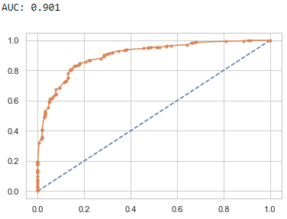

Fig 1.80 AUC and ROC curve train data of ABCL

The probability of the Area under the ROC curve for the train data is 87.1%

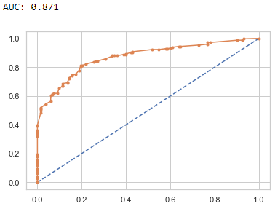

Fig 1.81 AUC and ROC curve test data of ABCL

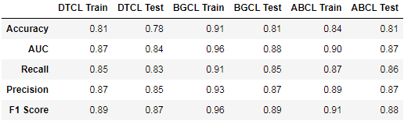

Fig – 1.82 Comparing Decision tree Classifier) vs. Bagging classifier (Using Random forest algorithm) vs. Adaboosting classifier

From the above comparison table, we can infer that Bagging classifier gives the best result for training dataset and testing dataset.

### 1.7 Performance Metrics: Check the performance of Predictions on Train and Test sets using Accuracy, Confusion Matrix, Plot ROC curve and get ROC_AUC score for each model. Final Model: Compare the models and write inference which model is best/optimized.

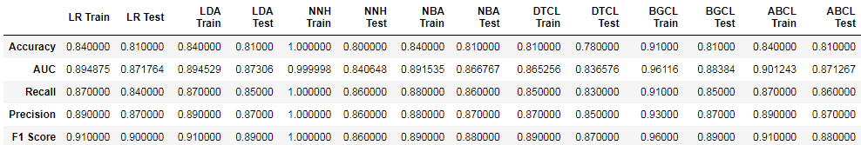

Fig – 1.83 Comparing output from each model.

Inference from the above table is, K-Nearest neighbour gives best result for train data but practically 100 result is an overfitting model, So bagging classifier (using Random Forest classifier) gives the best result for training data, whereas Logistic Regression gives best result for test data.

The bagging classifier (using Random Forest classifier) gives the best result for both training and test data

### 1.8 Based on these predictions, what are the insights?

***Predictions :***

Based on these prediction from the each model, we can infer that leading news channels CNBE analysed over the recent election and predicted that 81% of the voter will vote for the party. The Winning party will get 81% seat in the election. The rest 19% of the seat will be occupied by the opposiion party.

***Insights :***

1. Voter with age 40 - 80 are casting their vote in the election, whereas the young people are not casting their vote. Some awarness needs to be created for the young people to cast their vote.

2. Tourism boosts the revenue of the economy, creates thousands of jobs, develops the infrastructures of a country, and plants a sense of cultural exchange between foreigners and citizens.

3. Foreingers will be attracted by the benefts of citizens of EU, Parties should be taken care of party

4. Only citizens should enjoy the benefits of the country, Tourist should leave the country and not to take benifits of citizens

***Recommendations :***

***Blair Manifesto for Labour party:***

1. Working hours will be reduced for the labour

2. Working benefits will be improved

3. Medical benefits will be improved

***Hague Manifesto for conservative party:***

1. Education will be made available for all

2. Medical benefits will be improved

3. Standard of living will be improved

4. Accessibility of financial facilities will be improved

5. Lending rates of bank will be reduced

6. Interest on deposits will be improved

# Problem – 2

*Summary*

In this particular project, we are going to work on the inaugural corpora from the nltk in Python. We will be looking at the following speeches of the Presidents of the United States of America. The purpose of this exercise is to perform the text analysis for the speeches given by the president of United States.

*Introduction*

The purpose of this exercise is to perform the text analysis for the speeches given by the president of United States of America. This inaugural corpora consist of speeches of every president of United states of America.

1. President Franklin D. Roosevelt in 1941
2. President John F. Kennedy in 1961
3. President Richard Nixon in 1973

Performing Text Analysis for these 3 president speeches.

### 2.1 Find the number of characters, words, and sentences for the mentioned documents



Fig – 2.1 Number of Character,words and sentences for President D.Roosevelt



Fig – 2.2 Number of Character,words and sentences for President F. Kennedy



Fig – 2.3 Number of Character, words and sentences for President Richard Nixon

### 2.2 Remove all the stopwords from all three speeches.

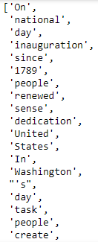

Fig – 2.4 Sample President Roosevelt speech after removing stopwords



Fig – 2.5 No of words count before and after removing of stopwords for President Roosevelt

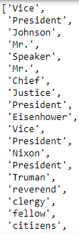

Fig – 2.6 Sample President Kennedy speech after removing stopwords



Fig – 2.7 No of words count before and after removing of stopwords for President Kennedy

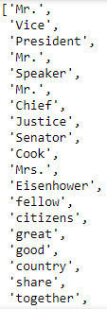

Fig – 2.8 Sample President Nixon speech after removing stopwords



Fig – 2.9 No of words count before and after removing of stopwords for President Nixon

### 2.3 Which word occurs the most number of times in his inaugural address for each president? Mention the top three words. (after removing the stopwords).



Fig – 2.10 Top 3 words from President Roosevelt speech

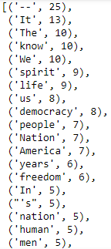

Fig – 2.11 Words occurred most number of time from President Roosevelt speech



Fig – 2.12 Top 3 words from President Kennedy speech

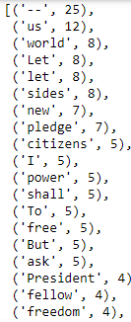

Fig – 2.13 Words occurred most number of time from President Kennedy speech



Fig – 2.14 Top 3 words from President Nixon speech

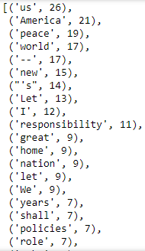

Fig – 2.15 Words occurred most number of time from President Nixon speech

### 2.4 Plot the word cloud of each of the speeches of the variable. (after removing the stopwords) – 3 Marks [ refer to the End-to-End Case Study done in the Mentored Learning Session ].

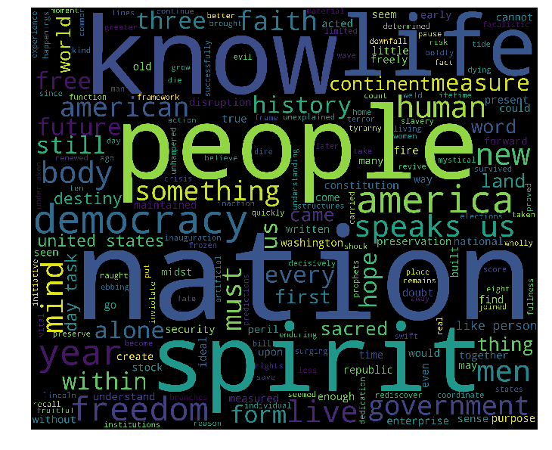

Fig – 2.16 Word cloud from President Roosevelt speech after removing stopwords

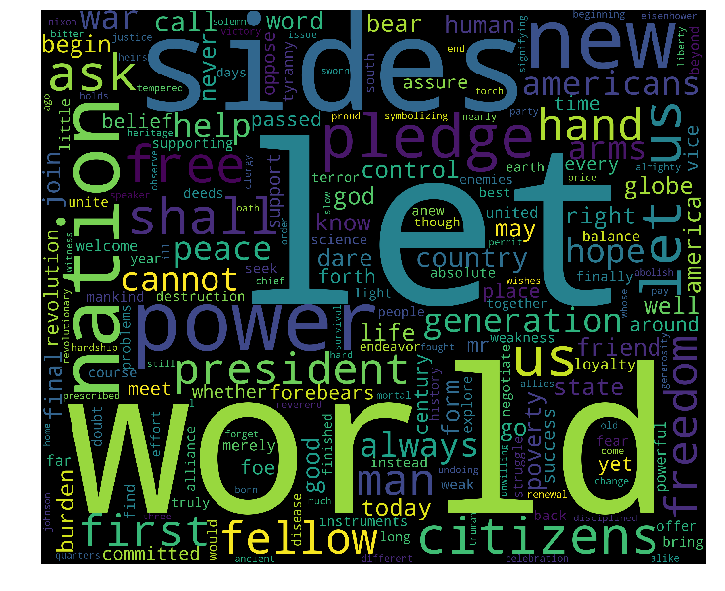

Fig – 2.17 Word cloud from President Kennedy speech after removing stopwords



Fig – 2.18 Word cloud from President Nixon speech after removing stopwords